Early Warning Signals: Integrating Academic, Socioeconomic, and Parental Predictors in Multi-Class Student Outcome Models
Abstract:
Student dropout represents an important challenge for higher education, associated with loss of human capital and institutional resources. Traditional “stay or go” predictive models often fail to capture the complex nature of student trajectories. Therefore, this study develops a robust Early Warning System (EWS) to predict three student outcomes: dropout, continued enrollment, and graduation. Utilizing the comprehensive SATDAP dataset (N=4,424 students, 2010–2018), the study integrates four predictor groups: early academic performance, parental education, demographic and socioeconomic factors, and regional macro-indicators. We compare five types of models, including traditional econometrics (multinomial logistic regression) and advanced machine learning techniques. We find that non-linear machine learning methods are most suitable for accurate multi-class prediction, with XGBoost achieving the best overall performance. The strongest predictors of student outcomes are first-semester average grades and approved credit units, which largely supersede initial admission scores. Among non-academic factors, up-to-date tuition fees and age at enrollment are key determinants, while parental education shows a limited effect after academic performance is factored in. These findings can encourage higher education institutions design Early Warning Systems and implement targeted interventions to reduce dropout rates.
Keywords: Student dropout prediction, learning analytics, Machine learning, Parental education.

- Introduction
Student dropout (understood as withdrawal from studies or failure to complete them) is a very important problem from the perspective of managing educational quality and university development in general and for institutional accreditation processes in particular. For instance, university accreditation procedures commonly analyze key performance indicators such as study completion rates, student retention, and institutional efforts to minimize student withdrawal. As a consequence, many universities implement more or less advanced Early Warning Systems (EWS) as tools of institutional support. These systems enable the early identification of students at risk and facilitate appropriate intervention in form of academic and financial support (Bañeres et al., 2020; Bañeres et al., 2023; Macfadyen & Dawson, 2010; Jayaprakash et al., 2014). Research on this topic is also motivated by current demographic shifts and the increasing significance of learning analytics within the higher education sector. Therefore, investigating the efficacy of Early Warning Systems is relevant for addressing major challenges in educational quality management in many countries. From a broader perspective, successful implementation of EWS also supports long-run accumulation of human capital the economy.
Researchers have long sought to predict student dropout. In this study dropout is defined as a student leaving the system without graduating from their program or without registering for another program. In the literature, this concept is mostly modeled in a binary manner. However, this approach does not adequately distinguish between the different ways students end their education. To address this limitation, our study proposes a multi-class framework that considers student attendance status as a three-class outcome variable: dropping out, staying enrolled, or graduating (cf. Kuh et al., 2006; York et al., 2015; Kemper et al., 2020; Forti, Grilli, and Rampichini, 2025). This three-part structure allows for a more detailed analysis of students’ enrollment status and potential trajectories. Furthermore, while previous work focused on early prediction (cf. Martins et al., 2021), our study extends this work by integrating traditional student-level data (such as early academic measures like first- and second-semester grades and the number of credits successfully completed) with regional macro-indicators, reflecting the multifaceted nature of academic progress.
This paper seeks to answer the following research questions:
RQ1. How well do early academic results predict whether a student will drop out, enroll to another program, or graduate?
RQ2. How do a student’s mother’s and father’s education levels affect their chances of staying in school or graduating?
RQ3. Which type of model makes the most accurate and reliable predictions of student outcomes (traditional econometric models, linear ML models, or non-linear ML models)?
To answer these questions, we employ and compare performance of both econometric methods (multinomial logistic regression) and linear (linear SVM) and non-linear machine-learning approaches (Random Forest, XGBoost). Model efficacy is evaluated using macro-F1, balanced accuracy, and log-loss. Our analysis demonstrates that early academic measures, including first-semester grades and completed credit units, are strong predictors of final student outcomes. While demographic and financial characteristics (age at enrollment, gender, nationality, scholarship status, debt status) contribute additional explanatory value, we find that the effect of parental education is limited once early academic performance is considered.
The remainder of the paper is structured as follows. Section 2 presents the main findings and methodological approaches discussed in the literature. Section 3 describes the data and methods employed in this study. Section 4 focuses on empirical results, while the final section concludes.
- Literature Review
Research on predicting student achievement and dropout rates in higher education has emphasized the multidimensional nature of student trajectories, shifting from early binary dropout predictions to models that suggest the combined examination of academic, socioeconomic, and institutional factors. Research aimed at predicting student achievement and dropout rates in higher education has increased significantly over the last two decades, particularly in terms of prediction objectives and methodological approaches. In this literature review, guided by our research questions, existing works are grouped into two clusters: one focused on determinants of student academic outcomes and the second on methodological approaches in student outcome prediction.
2.1. Determinants of student academic outcomes
Academic performance is typically related to measurable academic outcomes achieved by a student during their first academic year at university, such as first- and second-semester grades and the number of credits successfully completed. While some studies limit academic performance to grade point averages, others include indicators of student progress such as credit accumulation and course pass rates. In this study, both types of indicators are used together to reflect the multifaceted nature of academic progress (cf. Tinto, 1975; 1993; OECD, 2019).
Findings on the determinants of student outcomes accentuate the role of early academic performance alongside socioeconomic and demographic factors, with studies generally focusing on a binary “stay or go” outcome. Among the important findings is that early academic performance strongly predicts student retention rates. First-year academic performance also predicts differences in the number of credits successfully completed, course pass rates, student graduation rates, and dropout rates (Akçapınar et al., 2019; Kustitskaya et al., 2022; Realinho et al., 2021; Mahboob et al., 2023). Early academic experiences are decisive, with first-year students being most likely to drop out of school (Herzog, 2005; Shiao et al., 2023). In a similar vein, the difficulty of science and health courses increases students’ risk of dropping out of school (Arias Ortiz & De Hong, 2013). Regarding demographic variables, gender has no significant relationship with academic performance (Golding, 2019), while age and student suitability for the program have an indirect effect on the rates of advanced education (Herzog, 2005; Zimmermann et al., 2011; White et al., 2024).
When socioeconomic and financial factors are considered, a more consistent pattern emerges (Valiyev et al., 2025). Students from economically disadvantaged families have a higher dropout rate (Villegas-Ch. et al., 2023). Conversely, students receiving financial support such as scholarships are more likely to achieve academic success (Ishitani & Snider, 2006; Rumberger, 2011; Jokhan et al., 2022). With regard to parental education, some studies indicate that family education level may have an effect on academic performance (Ishitani & Snider, 2006), while studies that examine this effect separately for mother’s and father’s education levels in a multivariate structure remain limited. Furthermore, economic conditions and institutional factors have a statistically significant effect on students’ decisions to continue their education (Delogu et al., 2024), and examining these variables together increases the predictive power of analysis.
2.2. Methodological approaches in student outcome prediction
Traditional research largely evaluated student status as a binary outcome variable (dropout vs. non-dropout), applying both econometric methods and machine learning techniques. Hoffait & Schyns (2017) compare traditional econometric methods (logistic regression) and advanced machine learning techniques (artificial neural networks, random forests) to find that the predictive abilities of these three methods were the same. Golding et al. (2019) perform stepwise regression analysis, concluding that demographic variables have a limited effect on academic performance. In addition to these findings, the number of studies using machine learning methods, which can model nonlinear relationships and complex interactions, is increasing. It is well known that advanced algorithms are effective in improving prediction accuracy. Recent studies confirm this across various institutional contexts: Martinez et al. (2024) demonstrate that machine learning models reliably identify at-risk students in the early stages of the enrollment process; Skittou et al. (2024) are developing an Early Warning System using machine learning to support educational planning; Alalawi et al. (2024) propose an expanded framework that integrates machine learning with pedagogical interventions, and Yu et al. (2021) note that recurrent neural networks offer a computationally efficient approach for early warning in online STEM learning. For example, Beaulac & Rosenthal (2019) report high prediction accuracy for graduation outcomes at the University of Toronto by applying a random forest classifier to rich academic datasets.
Binary models that evaluate current students and graduates within the same group cannot make effective distinctions between different educational outcomes. The limitations of these models support the increase in studies on multi-class clustering methods (Alalawi et al., 2023; Oliveira et al., 2021; Liz-Domínguez et al., 2019). Systematic reviews show that machine learning approaches are increasingly outperforming traditional binary models in capturing students’ complex developmental trajectories across multiple outcome categories. Studies explaining the preference for multi-class outcome structures and more integrated analytical frameworks are increasing after 2020. Kemper et al. (2020) state that even simple models show high performance when incorporating early academic indicators and emphasize the importance of time-dependent data in early warning systems. Martins et al. (2023) propose a multi-class and multi-stage structure that can predict students’ academic trajectories at different levels of the program, arguing that continuation and graduation variables should be separated. Rabelo & Zarate (2025) propose a structure that combines logistic regression, decision trees, and neural network models to explain multi-category results, while Forti et al. (2025) propose a complex multivariate model that accounts for unobservable heterogeneity. According to these studies, student outcomes are heterogeneous and cannot be accurately captured using binary models.
Despite these developments, two research gaps remain. First, there are very few studies systematically comparing econometric models and non-linear machine learning algorithms using the same data sets and performance measures. Second, there are limited studies that examine a comprehensive set of factors (academic performance, parental education, financial status, and macroeconomic indicators) solely through a multi-class modeling structure.
2.3. Contribution of the study to the literature
This study addresses the gaps identified in the literature from three perspectives. First, it models the students’ situation as a three-tiered outcome variable: dropout, continuation of education, and graduation, highlighting different educational trajectories overlooked by binary approaches. Second, it integrates early academic indicators, parental education levels, demographic characteristics, financial variables, and regional macroeconomic indicators. The final aspect that makes the research significant is its systematic comparison of traditional econometric methods with contemporary machine learning approaches, using the same training-validation-test splits and multiple performance measures. Because of these aspects, the study provides a unique contribution to the literature on the development of early warning systems in higher education.
- Data and Methods
  - Data
In this study, we use a licensed dataset obtained from a medium-sized university in Portugal and compiled within the SATDAP initiative (grant no. POCI-05-5762-FSE-000191). The main purpose of the study is to help higher-education institutions identify students who may be struggling as early as possible and to support them before problems become irreversible. It assists students to stay on track and complete their degrees. This dataset includes administrative and academic records for 4,424 students who enrolled between 2010 and 2018. The dataset captures both academic information and socio-economic indicators of students’ such as age, gender, family income, and parents’ educational background. We take students’ status as a multinomial classification task with three categories:
- Dropout: The student leaves the system before graduation.
- Continued enrollment: The student remains enrolled and continues their education.
- Graduation: The student successfully completes their program.
Table 1. Definition of Variable Groups.
Variable Type | Variables
Demographic & financial | age at enrollment, gender, nationality, scholarship, debtor status.
Parental background | mother’s and father’s highest qualification.
Early academic performance | admission grade (on a 0–200 scale), first-semester approved credit units, and first-semester grade average.
Macro-level indicators | regional unemployment rate, inflation rate, and GDP per capita for the student’s home region.
Outcome | student status at the end of study.
Source: Own elaboration.

Table 1 provides a structured overview of the operationalized variable groups and their respective constituent metrics utilized across all model specifications. The data structure simultaneously accounts for pre-enrollment attributes (such as demographic background and parental education), institutional integration factors (early academic performance), and exogenous economic pressures (macro-level indicators). This holistic approach ensures that the estimation of the primary outcome measure student status at the end of the study period is strictly controlled for both internal and external confounding dynamics.
Table 2. Descriptive Statistics
Variable | Mean | Standard Deviation (SD) | Minimum (Min) | Maximum (Max)
Previous qualification grade | 132.61 | 13.19 | 95 | 190
Admission grade | 126.98 | 14.48 | 95 | 190
Age at enrollment | 23.27 | 7.59 | 17 | 70
Curricular units 1st sem (grade) | 10.64 | 4.84 | 0 | 18.88
Curricular units 2nd sem (grade) | 10.23 | 5.21 | 0 | 18.57
Unemployment rate | 11.57 | 2.66 | 7.6 | 16.2
Inflation rate | 1.23 | 1.38 | -0.8 | 3.70
GDP growth rate | 0 | 2.27 | -4.06 | 3.51

Looking at the descriptive statistics in Table 1 above, the average age at which students enrol at university is 23.27. Whilst the students’ previous average grade point average was 132.61, their average admission score is shown as 126.98. Over the course of an academic year, the average course mark in the first term was 10.64, whilst the average course mark in the second term was 10.23, which is similar to that of the first term. In both semesters, the fact that the minimum course marks are zero indicates that the relevant students were absent from the courses or failed them. Students’ absence from courses or failure in them can be considered a situation that may lead to them dropping out of school early. Looking at the macroeconomic data, whilst the average inflation rate of 1.23% can be considered positive from a macroeconomic perspective, the average unemployment rate is observed to be at a high level of 11.57%. When the table is assessed as a whole, the differences in students’ grade situations, demographic data and the country’s macroeconomic levels indicate the suitability of the model for making predictions.
  - Predictive Models
In this study, we apply two complementary approaches for prediction: a multinomial logistic regression model from econometrics and four machine learning models.
Table 2. Characteristics of predictive models
Model type | Model name | Characteristics of the model
Econometric | Multinomial Logistic Regression | Estimates the log-odds of each outcome category via a linear combination of predictors providing interpretable coefficients (LaValley, 2008; Hosmer Jr., Lemeshow, & Sturdivant, 2013)
Linear Machine Learning | Support Vector Machine | Finds the optimal linear hyperplane in feature space that maximally separates outcome classes (Mammone et. al, 2009; Ghosh et. al., 2019)
Non-linear ML | Support Vector Machine (Kernel SVM) | Uses a non-linear kernel to project data into higher-dimensional space, enabling separation of complex class boundaries (Dagher, 2008; Zhang, 2008)
Non-linear Machine Learning (Bagging) | Random Forest | creates multiple decision trees on randomly sampled data and combines their results to make a final decision (Pal, 2005; Belgiu & Drăguţ, 2016; Rodriguez-Galiano et.al, 2012)
Non-linear ML (Boosting) | XGBoost | implements gradient boosting to iteratively minimize residual errors through the addition of decision trees (Chen, 2016; Prabha et. al., 2021)

Table 2 presents the five predictive models used in this study and groups them into three broad families: an econometric baseline, linear machine learning models, and non-linear machine learning methods.
We used three distinctive metrics to evaluate the performance of the predictive models.
- macro-F1 (the simple average of per-class F1 scores, which balances precision and recall equally across all outcome categories),
- balanced accuracy (the average of sensitivity and specificity, which corrects for imbalanced class sizes), and
- log-loss (a measure of how confidently and correctly a model assigns probabilities to each class).

  - Exploratory Data Analysis
Fig. 1. Target Variable Distribution
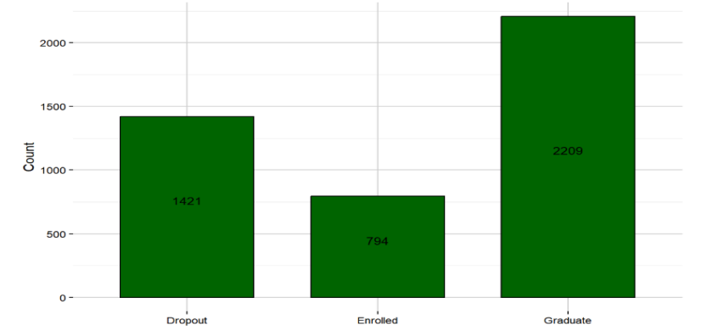
Source: SATDAP
In Figure 1, we see a bar plot which shows that there is a class imbalance in the dataset, where most students graduated (2,209), fewer dropped out (1,421), and smallest number are still enrolled (794). This imbalance can lead to bias in model results. A model could achieve high accuracy just by predicting most students as graduates because they are the majority of class.
Fig. 2. Admission Grades by Gender and Student Outcome 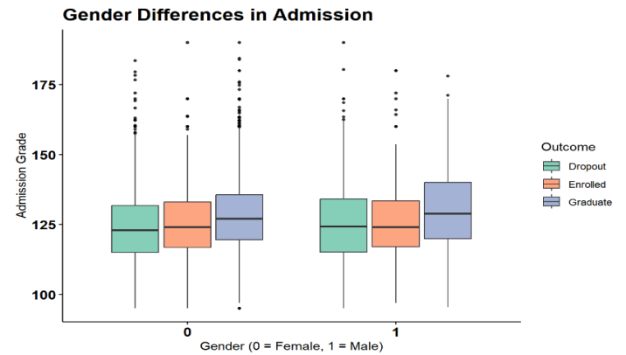
Source: SATDAP
Figure 2 illustrates how initial admission scores relate to the three student outcomes: Dropout, Enrolled, and Graduate, shown separately for females (0) and males (1). In both groups, students who eventually graduate tend to enter with slightly higher admission grades than those who later drop out. Students who remain enrolled usually fall between these two outcomes.
Fig. 3. Student Outcomes Across Parent’s Education Levels
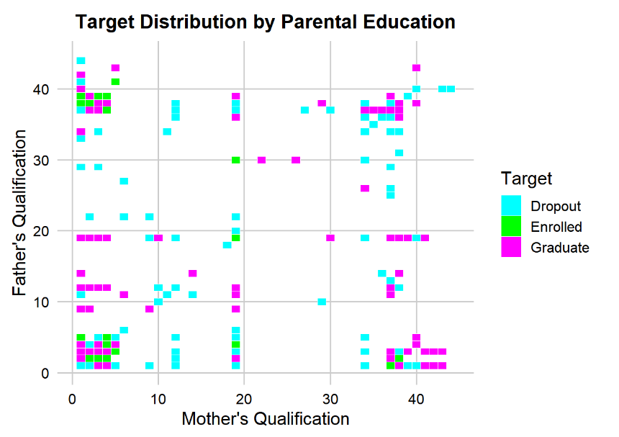
Source: SATDAP
Figure 3 shows the relationship between parents’ qualification levels and student status. The x-axis represents the mother’s qualification and the y-axis represents the father’s qualification. The scale on both axes follows the coded qualification categories used in the dataset, where each numeric value corresponds to a specific education level category. In general, higher coded values indicate higher qualification levels.
Each point represents one student, based on the qualification levels of the mother and father. The colors show the student’s final status: dropout, enrolled, or graduate. The figure shows strong overlap between the three groups, meaning that parental qualification alone does not clearly separate dropout, enrolled, and graduate students. However, the pattern suggests that students whose parents have higher qualification levels are slightly more likely to graduate.
3.4.1. Data Split
We allocate 3,098 students (70% of the sample) to the training set, where the models learn the underlying patterns. The validation set includes 885 students (20%) and is used to tune hyperparameters and choose the best-performing specifications. The remaining 441 students (10%) are in the test set.
3.4.2. Multicollinearity Handling for Econometric Modeling
Variance inflation factors (VIFs) were evaluated to ensure model robustness of the linear models. A commonly accepted threshold for variance inflation factors (VIFs) is 10. Variables which are higher than this threshold cause multicollinearity issue and required to be removed (Tay, 2017). In addition, after modifying, it is crucial to recalculate the VIF values to make sure the multicollinearity problem has been properly solved.
Table 4. VIF Scores Feature Exclusion.
No | Variable | VIF Score | VIF Score Updated
1 | Previous.qualification..grade. | 1.565 | 1.563
2 | Admission.grade | 1.596 | 1.593
3 | Age.at.enrollment | 1.170 | 1.128
4 | Curricular.units.1st.sem..credited. | 15.898 | excluded
5 | Curricular.units.1st.sem..enrolled. | 23.038 | excluded
6 | Curricular.units.1st.sem..evaluations. | 3.787 | 3.082
7 | Curricular.units.1st.sem..approved. | 12.244 | excluded
8 | Curricular.units.1st.sem..grade. | 4.900 | 3.690
9 | Curricular.units.1st.sem..without.evaluations. | 1.764 | 1.761
10 | Curricular.units.2nd.sem..credited. | 12.337 | 2.100
11 | Curricular.units.2nd.sem..enrolled. | 16.140 | 2.594
12 | Curricular.units.2nd.sem..evaluations. | 3.101 | 2.840
13 | Curricular.units.2nd.sem..approved. | 9.703 | excluded
14 | Curricular.units.2nd.sem..grade. | 5.349 | 3.411
15 | Curricular.units.2nd.sem..without.evaluations. | 1.649 | 1.637
16 | Unemployment.rate | 1.190 | 1.167
17 | Inflation.rate | 1.037 | 1.031
18 | GDP | 1.221 | 1.218

Table 5 checks for multicollinearity before estimating the multinomial logit model by using VIF values and VIF scores after excluding collinear variables. The majority of the variables, such as previous qualification grade, admission grade, age, and macro indicators, have low VIF values (around 1 to 1.6). This means they are not strongly related to each other and provide mostly independent information. In comparison, some semester-related variables have high VIF values, especially first semester enrolled (23.04) and first semester credited (15.90). Many of them are above 5-10 along with other semester variables. This suggests stronger multicollinearity among these variables. This means these academic variables are closely related because they measure similar aspects of student performance. As a result, this can make the regression results unstable. So, we understand this as a sign that we should either remove some of the highly related semester variables or combine them, to make sure the econometric results are stable and easy to interpret. It shows the new VIF values after removing four highly related semester variables. The results indicate that the multicollinearity problem has been greatly reduced The remaining variables now have low or moderate VIF values.
Table 6. Variable Information
Variable | Type | Used In | Notes
Student status (dropout/continued/graduation) | Target | Both | Outcome variable
Admission grade | Predictor | Both | 0–200 scale
First-semester approved units | Predictor | Both | Core early-performance metric
First-semester grade average | Predictor | Both | Early performance indicator
Mother’s highest qualification | Predictor | Both | Parental education
Father’s highest qualification | Predictor | Both | Parental education
Age at enrollment | Predictor | Both | In years
Gender | Predictor | Both | One-hot encoded
Nationality | Predictor | Both | One-hot encoded
Scholarship status | Predictor | Both | Binary indicator
Debtor status | Predictor | Both | Binary indicator
Unemployment rate | Control | Both | Regional economic indicator
Inflation rate | Control | Both | Regional economic indicator
GDP per capita | Control | Both | Regional economic indicator
Curricular.units. 1st.sem.enrolled | Predictor | Non-Linear ML only | Removed for multicollinearity in econometric
Curricular.units. 1st.sem.credited | Predictor | Non-Linear ML only | Removed for multicollinearity in econometric
Curricular.units. 1st.sem.approved | Predictor | Non-Linear ML only | Removed for multicollinearity in econometric
Curricular.units. 2nd.sem.approved | Predictor | Non-Linear ML only | Removed for multicollinearity in econometric
Source: Own elaboration.
In Table 6, we observe comprehensive overview of the variables used in the analysis and explains how they were included in the two modeling frameworks: econometric and machine learning. It is key to mention that the same main predictors are used in both models to make the comparison fair. Some semester-related variables are used only in the non-linear machine learning models. They are removed from the econometric model because they caused strong multicollinearity, which would make the regression results less reliable.
- Empirical Results
Table 7. Model Results
No | Model | Dataset | Macro F1 | Balanced Accuracy | Log Loss
1 | Logistic Regression | Train | 0.6333 | 0.8097 | 0.6662
2 | Logistic Regression | Validation | 0.6214 | 0.8089 | 0.6649
3 | Logistic Regression | Test | 0.6609 | 0.8507 | 0.6367
1 | Linear SVM | Train | 0.6253 | 0.8012 | 0.6725
2 | Linear SVM | Validation | 0.6131 | 0.8029 | 0.6601
3 | Linear SVM | Test | 0.6532 | 0.8438 | 0.6381
1 | Non-linear SVM | Train | 0.7749 | 0.8830 | 0.4553
2 | Non-linear SVM | Validation | 0.6997 | 0.8650 | 0.5423
3 | Non-linear SVM | Test | 0.6994 | 0.8628 | 0.5545
1 | Random Forest | Train | 0.6727 | 0.8542 | 0.5565
2 | Random Forest | Validation | 0.5735 | 0.8356 | 0.7469
3 | Random Forest | Test | 0.6151 | 0.8799 | 0.6847
1 | XGBoost | Train | 0.8093 | 0.8903 | 0.4134
2 | XGBoost | Validation | 0.6950 | 0.8417 | 0.5320
3 | XGBoost | Test | 0.7144 | 0.8887 | 0.5343
Source: Own elaboration.
Table 7 compares how well five different models perform on the training, validation, and test datasets. The performance is measured using Macro-F1, balanced accuracy, and log loss. From the results, XGBoost is the best-performing model. It achieves the highest scores in most of the tests and also has a low log loss, which means its predictions are more accurate and reliable. The non-linear (kernel) SVM is the second best model, also performs well across the datasets, but its results are slightly worse than XGBoost. The other models, logistic regression, linear SVM, and random forest perform worse and their results are lower and are not as consistent. When looking specifically at the test dataset, XGBoost again gives the best results with the highest Macro-F1 score (0.7144) and balanced accuracy (0.8887), along with a low log loss 0.5343. SVM model also performs well, but it scores slightly lower than XGBoost.
Simpler models such as logistic regression and linear SVM achieve moderate balanced accuracy on the test dataset, however, their Macro-F1 scores are low (0.6609 and 0.6532). This means they do not perform well on minority classes, even though their balanced accuracy looks acceptable. The random forest model has a high balanced accuracy (0.8799), but its Macro-F1 score (0.6151) and log loss (0.6847) are worse. This means that the model does not perform consistently across all classes and its probability predictions are less reliable.
  - Econometric Logistic Model Results
Table 8. Model Results (Logistic Regression)
No | Predictor | Outcome Comparison (reference category: Dropout) | Coef. | SE | z-value | p-value | Significant?
1 | Admission grade | Enrolled | 0.054 | 0.079 | 0.68 | 0.50 | No
1 | Admission grade | Graduate | 0.138 | 0.074 | 1.86 | 0.06 | No
2 | First-sem. approved units | Enrolled | 0.086 | 0.118 | 0.73 | 0.47 | No
2 | First-sem. approved units | Graduate | 0.484 | 0.139 | 3.48 | 0.0005 | Yes
3 | First-sem. grade average | Enrolled | 0.979 | 0.116 | 8.44 | <0.0001 | Yes
3 | First-sem. grade average | Graduate | 1.793 | 0.146 | 12.28 | <0.0001 | Yes
4 | Tuition fees up to date | Enrolled | 2.159 | 0.237 | 9.10 | <0.0001 | Yes
4 | Tuition fees up to date | Graduate | 2.939 | 0.277 | 10.61 | <0.0001 | Yes
5 | Scholarship holder | Enrolled | 0.278 | 0.180 | 1.55 | 0.12 | No
5 | Scholarship holder | Graduate | 1.101 | 0.159 | 6.92 | <0.0001 | Yes
6 | Mother’s qualification | Enrolled | –0.027 | 0.009 | –2.84 | 0.0045 | Yes
6 | Mother’s qualification | Graduate | –0.015 | 0.009 | –1.69 | 0.09 | No
7 | Father’s qualification | Enrolled | 0.001 | 0.008 | 0.10 | 0.92 | No
7 | Father’s qualification | Graduate | 0.006 | 0.007 | 0.08 | 0.94 | No
8 | Age at enrollment | Enrolled | –0.433 | 0.092 | –4.69 | <0.0001 | Yes
8 | Age at enrollment | Graduate | –0.388 | 0.084 | –4.62 | <0.0001 | Yes
9 | Unemployment rate (region) | Enrolled | –0.237 | 0.069 | –3.42 | 0.0006 | Yes
9 | Unemployment rate (region) | Graduate | –0.022 | 0.066 | –0.32 | 0.75 | No
Source: Own elaboration.
Table 8 describes econometric logistic regression model results where first-semester performance and financial stability are the most important factors in separating dropouts from graduates. First-semester average grades have a crucial role in both comparisons. Students who perform well early in their studies are much more likely to continue and especially to graduate. Financial stability is also a key factor who keeps tuition payments on time has the strongest positive effect for both outcomes. This shows that students who are financially stable and meet administrative requirements are more likely to complete their studies. For long-term success, the number of courses passed in the first semester is significant factor. It matters when comparing graduates to dropouts, but it is not while comparing enrolled students to dropouts. This supports the idea that passing more courses over time helps students move toward completing their degree. Moreover, admission grades are no longer significant after considering first-semester performance. This means that what students achieve after enrolling matters more than how prepared they were at the beginning.
In the second part of the analysis we consider how students in the same academic environment can have different levels of vulnerability or risk. We detected that the age at enrollment has a negative effect in both comparisons. It means that older students are more likely to drop out compared to young students. This shows that older students need early support, such as help managing work and studies or access to more flexible study options. Scholarship status does not strongly influence whether students stay enrolled. Nevertheless, it becomes crucial when comparing graduates to dropouts. It suggests that financial support is required more for helping students finish their degree than just helping them stay enrolled at the beginning. Additionally, parental education overall does not have a strong effect. The father’s education is not statistically significant, while the mother’s education shows a small but significant negative effect when comparing enrolled students to dropouts. Therefore, parental education should not be seen as a main cause of dropout. Finally, regional unemployment is only significant when comparing enrolled students to dropouts, and the relationship is negative. This suggests that difficult economic conditions may push students to leave their studies during that time, even though these conditions do not clearly distinguish future graduates from dropouts.
  - XGBoost Model
Fig. 5. Top 20 most effective features in XGBoost Model
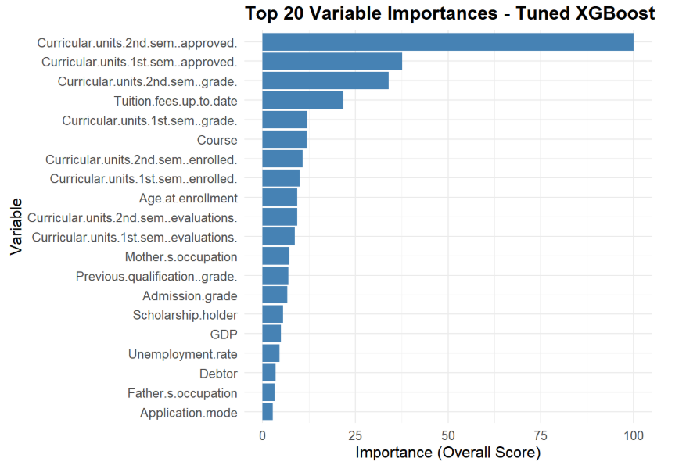
Figure 5 shows top features in descending order to predict student’s performance by best-performing model (XGBoost). The significant factors are mainly related to academic progress, especially the number of courses passed in the first and second semesters. The grades achieved from those semesters are also essential variables. In general, the model mainly focuses strongly on whether students pass their courses and earn credits. This makes sense, because students who do not make academic progress are more likely to leave. After academic performance, paying tuition fees on time is one of the essential variables. This shows that financial and administrative stability is necessary for staying in the program and successfully graduating.
The results show that students’ grades and performance in the first year are the strongest indicators to predict future outcomes. So, demographic information can not replace the importance of actual academic performance data. Other factors such as course type, enrollment size, age at entry, and previous academic performance are much lower compared to first-year academic results. Broader economic factors like GDP and unemployment, as well as family-related factors such as parents’ jobs, are less important. They give background information, but they do not affect predictions as much as students’ current academic engagement. In summary, the results show that study progress and regular tuition payment is the main signal for predicting their future results. Therefore, universities should focus on helping students who are earning few credits or whose grades are getting worse, especially if they are also facing financial problems.

Fig. 6. Key Determinants of Predictive Outcomes

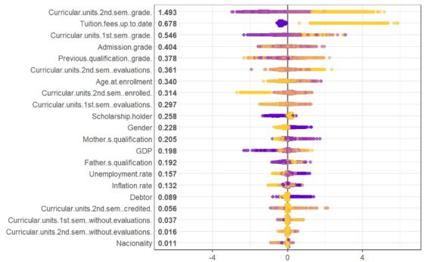
Figure 6 above shows the extent to which each predictor contributes to the output of the XGBoost model. Each point in the figure indicates the direction and magnitude of the effect along the horizontal axis. In terms of colour, purple indicates a low raw value, whilst yellow indicates a high raw value. According to the findings shown in the figure, early-stage academic success appears to be the dominant variable group compared to the other groups. The second-term grade point average ranks first with a value of 1.493, followed by tuition fees at 0.678 and the first-term grade point average at 0.546. When the reasons for dropping out of education are examined, it is observed that students with a low grade point average are more likely to drop out than those with a high grade point average. The ability to pay tuition fees is also the strongest non-academic indicator for students to continue their education. This is consistent with the dropout rates shown in Table (8). Differences in parents’ educational levels and the country’s macroeconomic situation are clustered at a value very close to zero. This indicates that, when based on academic signals, marginal contributions are negligible. The SHAP analysis confirms that these factors vary across educational periods and that students’ school attendance and financial conditions provide significant signals in identifying school dropout.

Concluding remarks
This study developed an Early Warning System (EWS) using a multi-class framework to predict student outcomes (dropout, staying enrolled, or graduation) based on the SATDAP higher-education dataset, which includes 4,424 students studied between 2010 and 2018. The dataset incorporated early academic performance, parental education, demographic and financial variables, and regional economic indicators.
Our findings clearly address the research questions formulated in the introduction. First, early academic performance is the strongest predictor of student outcomes. In particular, first-semester grades and approved credit units are the primary signals, overshadowing initial admission grades (RQ1).This finding is consistent with the adaptation processes described in Tinto’s (1975, 1993) and (White et al., 2024) work regarding the continuity of educational activities. It is also consistent with the study by Herzog (2005), which found that university students face a higher risk of dropping out in their first year compared to subsequent years. Similarly, Akçapınar et al. (2019) and Kustitskaya et al. (2022) confirm that early academic indicators such as credit completion and course grades are reliable signals for identifying at-risk students.
Second, among non-academic factors, up-to-date tuition fees were the strongest predictor, while age at enrollment showed a significant negative effect on persistence and graduation. In contrast, parental education showed almost no effect and offered no clear separation across outcome groups once early academic performance was accounted for (RQ2). Consequently, this finding differs from studies highlighting the importance of family background, such as educational attainment (Ishitani & Snider, 2006; Kemper et al., 2020), and indicates that socio-economic status is closely linked to academic performance. This is further supported by Villegas-Ch. et al. (2023) and Jokhan et al. (2022), who similarly find that financial stability is a stronger predictor of student persistence than parental education level. Taken together, the study demonstrates that the combination of early academic progress and financial stability are the most important predictors of dropout risk and student success.
Finally, regarding RQ3, non-linear machine learning methods proved most suitable for prediction. XGBoost achieved the best overall performance, demonstrating superior predictive accuracy and reliability across all outcome classes with a Macro-F1 score of 0.7144, balanced accuracy of 0.8887, and a low log loss of 0.5343. This approach is followed by the non-linear (kernel) SVM, showing that non-linear relationships are key in predicting student outcomes. In comparison, traditional econometric models (multinomial logistic regression) and linear ML models (linear SVM) achieved only moderate balanced accuracy, and their significantly lower Macro-F1 scores imply that they are inappropriate for accurately predicting minority classes, such as students who remain enrolled. Furthermore, while Random Forest showed high balanced accuracy, its lower Macro-F1 and higher log loss suggest that its probability predictions are less reliable and consistent across all outcome categories compared to XGBoost. These results are consistent with recent comparative studies showing that non-linear ML models, particularly gradient boosting methods, consistently outperform logistic regression and linear classifiers in multi-class student outcome prediction (Martinez et al., 2024; Alalawi et al., 2024).
The findings provide a clear basis for targeted university interventions. Given that early academic progress is the strongest signal, higher education institutions could front-load support services by proposing mandatory mid-term academic counseling for students who fail to earn their full first-semester credits. These interventions align with the adaptive systems reported in the literature that have been shown to be effective in improving student outcomes through targeted guidance and feedback (Rodríguez et al., 2022; Guerrero-Roldán et al., 2021; Raffaghelli et al., 2022). Since outstanding tuition fees were the strongest non-academic predictor, universities could implement flexible payment plans or emergency micro-grants to prevent administrative dropouts. Moreover, the negative impact of age at enrollment suggests a need for support dedicated to more mature students, who may have greater difficulties in balancing their external responsibilities.
Future research should validate the framework across other institutions, exploiting much larger datasets to analyze heterogeneity among universities and countries over longer time periods. Such analysis would enable confirming if the predictive power of regional economic factors, such as regional unemployment, remains constant during different national economic cycles and capturing the pace of demographic processes, including the declining overall number of individuals in analyzed age cohorts. Given the limited effect of parental education, future research could investigate some unobserved qualitative factors (e.g., study habits or psychological resilience) to understand better the mechanisms how students from diverse backgrounds succeed in the academia despite initial socioeconomic gaps. An interesting avenue of research is also to incorporate international students in such research. Future work could also conduct intervention efficacy studies. This could involve simulations, for example, predicting how a 10% increase in first-semester grades via tutoring would shift students from the “dropout” class to the remaining classes.
To conclude, proposed shows how institutional data from a historical record can be transformed into proactive tools supporting higher education systems.

References
- Akçapınar, G., Altun, A., & Aşkar, P. (2019). Using learning analytics to develop early-warning system for at-risk students. International Journal of Educational Technology in Higher Education, 16, 1–20.
- Alalawi, K., Athauda, R., & Chiong, R. (2023). Contextualizing the current state of research on the use of machine learning for student performance prediction: A systematic literature review. Engineering Reports, 5.
- Alalawi, K., Athauda, R., Chiong, R., & Renner, I. W. (2024). An extended learning analytics framework integrating machine learning and pedagogical approaches for student performance prediction and intervention. International Journal of Artificial Intelligence in Education, 35, 1239–1287.
- Arias Ortiz, E., & Dehon, C. (2013). Roads to success in the Belgian French community’s higher education system: Predictors of dropout and degree completion at the Université Libre de Bruxelles. Research in Higher Education, 54, 693-723.
- Bañeres, D., Rodríguez, M. E., Guerrero-Roldán, A. E., & Karadeniz, A. (2020). An early warning system to detect at-risk students in online higher education. Applied Sciences.
- Bañeres, D., Rodríguez-González, M., Guerrero-Roldán, A. E., & Cortadas, P. (2023). An early warning system to identify and intervene online dropout learners. International Journal of Educational Technology in Higher Education, 20, 1–25.
- Beaulac, C., & Rosenthal, J. S. (2019). Predicting university students’ academic success and major using random forests. Research in Higher Education, 60, 1048-1064.
- Belgiu, M., & Drăguţ, L. (2016). Random forest in remote sensing: A review of applications and future directions. ISPRS journal of photogrammetry and remote sensing, 114, 24-31.
- Chen, T. (2016). XGBoost: A Scalable Tree Boosting System. Cornell University.
- Credé, M., Roch, S. G., & Kieszczynka, U. M. (2010). Class attendance in college: A meta-analytic review of the relationship of class attendance with grades and student characteristics. Review of Educational Research, 80(2), 272–295. https://doi.org/10.3102/0034654310362998
- Dagher, I. (2008). Quadratic kernel-free non-linear support vector machine. Journal of Global Optimization, 41(1), 15-30.
- Delogu, M., Lagravinese, R., Paolini, D., & Resce, G. (2024). Predicting dropout from higher education: Evidence from Italy. Economic Modelling, 130, 106583.
- Forti, M., Grilli, L., & Rampichini, C. (2025). Accounting for unobserved heterogeneity in university dropout: A multinomial finite mixture approach. Journal of Applied Econometrics, 40(1), 98–117.
- Ghosh, S., Dasgupta, A., & Swetapadma, A. (2019, February). A study on support vector machine based linear and non-linear pattern classification. In 2019 International conference on intelligent sustainable systems (ICISS) (pp. 24-28). IEEE.
- Golding, C. (2019). Discerning student thinking: A practical theoretical framework for recognising or informally assessing different ways of thinking. Teaching in Higher Education, 24(4), 478-492.
- Guerrero-Roldán, A. E., Rodríguez-González, M., Bañeres, D., Elasri-Ejjaberi, A., & Cortadas, P. (2021). Experiences in the use of an adaptive intelligent system to enhance online learners' performance. International Journal of Educational Technology in Higher Education, 18.
- Herzog, S. (2005). Measuring determinants of student return vs. dropout/stopout vs. transfer: A first-to-second year analysis of new freshmen. Research in higher education, 46, 883-928.
- Hoffait, A. S., & Schyns, M. (2017). Early detection of university students with potential difficulties. Decision Support Systems, 101, 1-11.
- Hosmer Jr, D. W., Lemeshow, S., & Sturdivant, R. X. (2013). Applied logistic regression. John Wiley & Sons.
- Ishitani, T. T., & Snider, K. G. (2006). Longitudinal Effects of College Preparation Programs on College Retention. IR Applications. Volume 9. Association for Institutional Research (NJ1).
- Jayaprakash, S. M., Moody, E. W., Lauría, E., Regan, J. R., & Baron, J. D. (2014). Early alert of academically at-risk students: An open source analytics initiative. Journal of Learning Analytics, 1, 6–47.
- Jokhan, A., Chand, A. A., Singh, V., & Mamun, K. (2022). Increased digital resource consumption in higher educational institutions and the artificial intelligence role in informing decisions related to student performance. Sustainability.
- Kemper, L., Vorhoff, G., & Wigger, B. U. (2020). Predicting student dropout: A machine learning approach. European Journal of Higher Education, 10(4), 441–455. https://doi.org/10.1080/21568235.2020.1718520
- Kuh, G. D., Kinzie, J., Buckley, J. A., Bridges, B. K., & Hayek, J. C. (2006). What matters to student success: A review of the literature. National Postsecondary Education Cooperative.
- Kustitskaya, T. A., Kytmanov, A. A., & Noskov, M. (2022). Early student-at-risk detection by current learning performance and learning behavior indicators. Cybernetics and Information Technologies, 22, 117–133.
- LaValley, M. P. (2008). Logistic regression. Circulation, 117(18), 2395-2399.
- Liz-Domínguez, M., Caeiro-Rodríguez, M., Llamas-Nistal, M., & Mikic-Fonte, F. A. (2019). Systematic literature review of predictive analysis tools in higher education. Applied Sciences.
- Macfadyen, L. P., & Dawson, S. (2010). Mining LMS data to develop an "early warning system" for educators: A proof of concept. Computers & Education, 54, 588–599.
- Mahboob, K., Asif, R., & Haider, N. (2023). Quality enhancement at higher education institutions by early identifying students at risk using data mining. Mehran University Research Journal of Engineering and Technology.
- Mammone, A., Turchi, M., & Cristianini, N. (2009). Support vector machines. Wiley Interdisciplinary Reviews: Computational Statistics, 1(3), 283-289.
- Martins, M. V., Tolledo, D., Machado, J., Baptista, L. M., & Realinho, V. (2021, March). Early prediction of student’s performance in higher education: A case study. In World Conference on Information Systems and Technologies, 166-175.
- Martinez, A. L. J., Sood, K., & Mahto, R. V. (2024). Early detection of at-risk students using machine learning. ArXiv.
- OECD. (2019). Education at a glance 2019: OECD indicators. OECD Publishing. https://doi.org/10.1787/f8d7880d-en
- Oliveira, C. F., Sobral, S. R., Ferreira, M. J., & Moreira, F. (2021). How does learning analytics contribute to prevent students' dropout in higher education: A systematic literature review. Big Data and Cognitive Computing, 5, 64.
- Pal, M. (2005). Random forest classifier for remote sensing classification. International journal of remote sensing, 26(1), 217-222.
- Prabha, A., Yadav, J., Rani, A., & Singh, V. (2021). Design of intelligent diabetes mellitus detection system using hybrid feature selection based XGBoost classifier. Computers in Biology and Medicine, 136, 104664.
- Raffaghelli, J., Rodríguez, M. E., Guerrero-Roldán, A. E., & Bañeres, D. (2022). Applying the UTAUT model to explain the students' acceptance of an early warning system in higher education. Computers & Education, 182, 104468.
- Realinho, V., Vieira Martins, M., Machado, J., & Baptista, L. (2021). Predict Students’ Dropout and Academic Success [Dataset]. UCI Machine Learning Repository. https://doi.org/10.24432/C5MC89.
- Rodríguez, M. E., Guerrero-Roldán, A. E., Bañeres, D., & Karadeniz, A. (2022). An intelligent nudging system to guide online learners. The International Review of Research in Open and Distributed Learning.
- Rodriguez-Galiano, V. F., Ghimire, B., Rogan, J., Chica-Olmo, M., & Rigol-Sanchez, J. P. (2012). An assessment of the effectiveness of a random forest classifier for land-cover classification. ISPRS journal of photogrammetry and remote sensing, 67, 93-104.
- Rumberger, R. W. (2011). Dropping out: Why students drop out of high school and what can be done about it. Harvard University Press.
- Shiao, Y. T., Chen, C. H., Wu, K. F., Chen, B. L., Chou, Y. H., & Wu, T. N. (2023). Reducing dropout rate through a deep learning model for sustainable education: long-term tracking of learning outcomes of an undergraduate cohort from 2018 to 2021. Smart Learning Environments, 10(1), 55.
- Skittou, M., Merrouchi, M., & Gadi, T. (2024). Development of an early warning system to support educational planning process by identifying at-risk students. IEEE Access, 12, 2260–2271.
- Tay R (2017) Correlation, variance inflation and multicollinearity in regression model. J East Asia Soc Transp Stud 12: 2006‒2015. https://doi.org/10.11175/easts.12.2006
- Tinto, V. (1975). Dropout from higher education: A theoretical synthesis of recent research. Review of Educational Research, 45(1), 89–125. https://doi.org/10.3102/00346543045001089
- Tinto, V. (1993). Leaving college: Rethinking the causes and cures of student attrition (2nd ed.). University of Chicago Press.
- Valiyev, T., Batrancea, L. M., Aslan, T., & Abasova, U. (2025). A comparative analysis of GDP determinants in Germany and Poland: Integrating econometric and machine learning perspectives. National Accounting Review, 7(4), 501-521.
- Villegas-Ch., W., Govea, J., & Revelo-Tapia, S. (2023). Improving student retention in institutions of higher education through machine learning: A sustainable approach. Sustainability.
- White, H. C., Allen, D. M., Buffinton, K., Humphrey, D., Malpiede, M., Miller, R. K., ... & Yortsos, Y. C. (2024). Cultivating long-term well-being through transformative undergraduate education. PNAS nexus, 3(9), pgae372.
- York, T. T., Gibson, C., & Rankin, S. (2015). Defining and measuring academic success. Practical Assessment, Research & Evaluation, 20(5), 1–20. https://doi.org/10.7275/hz5x-tx03
- Yu, C. C., & Wu, Y. (2021). Early warning system for online STEM learning — A slimmer approach using recurrent neural networks. Sustainability.
- Zhang, Y. (2008). Fault detection and diagnosis of nonlinear processes using improved kernel independent component analysis (KICA) and support vector machine (SVM). Industrial & Engineering Chemistry Research, 47(18), 6961-6971.
- Zimmermann, J., Brodersen, K. H., Pellet, J. P., August, E., & Buhmann, J. M. (2011). Predicting Graduate-level Performance from Undergraduate Achievements. In EDM (pp. 357-358).

